Two Stage and Variable Capacity Model

Two Stage
The two speed model assumes there are two performance maps. The high stage capacity map defined by the normal AC data. The low stage performance map is defined by:

No | Description | DCK  Variable | Where Used
1 | Rated EER at low stage | AC_EER_lo | TYPE 140
2 | Rated SHR at low stage | AC_SHR_lo | TYPE 140
3 | Fraction of full capacity at low stage | tons_frac_lo | TYPE 140
4 | Fraction of full airflow at low stage | cfm_frac_lo | DCK file
5 | Fan Power (W/cfm) at low stage | wcfm_ac_lo | TYPE 140

The model checks for a non-zero value of AC_EER_lo to determine if the 2-speed algorithm should be used (when iac = 4).

The AC unit starts of at low stage. In Type 152 It must stay in low stage until the ON Time is greater than STG_delay. Once past this delay, High Stage can be activated (Hi_STG_c=1) when the control temperature (i.e. the temperature output from the thermostat model) is within 5% of the top of the dead band. High Stage turns off (Hi_STG_c=0) when the control temperature reaches 5% below the middle of the dead band.

Variable Capacity

The variable capacity model uses the same variables as in the table above, except the performance varies linearly between the high stage and low stage values. The nominal unit performance corresponds to the highest speed (usually 90 hz). When there is a non-zero value of AC_EER_lo and iac = 3 then the variable speed algorithm are used.

The the unit starts at the lowest stage (fspd = 0) and holds at that speed until the ON Time is greater than STG_delay. Then the speed signal is varied to maintain the control temperature (output from the thermostat) at the mid-point of the deadband. The parameters fhz_pgain and fhz_igain are proportional and integral gain used by the algorithm in Type 152. The maximum speed (fspd = 1) corresponds to nominal capacity, efficiency and airflow of the unit. These values are linearly extrapolated between the high and low values.
Example of two-speed AC performance
AC = 1 ton, 400 cfm, 0.35 W/cfm
Low speed = 50% capacity, 50% flow, 0.3 W/cfm
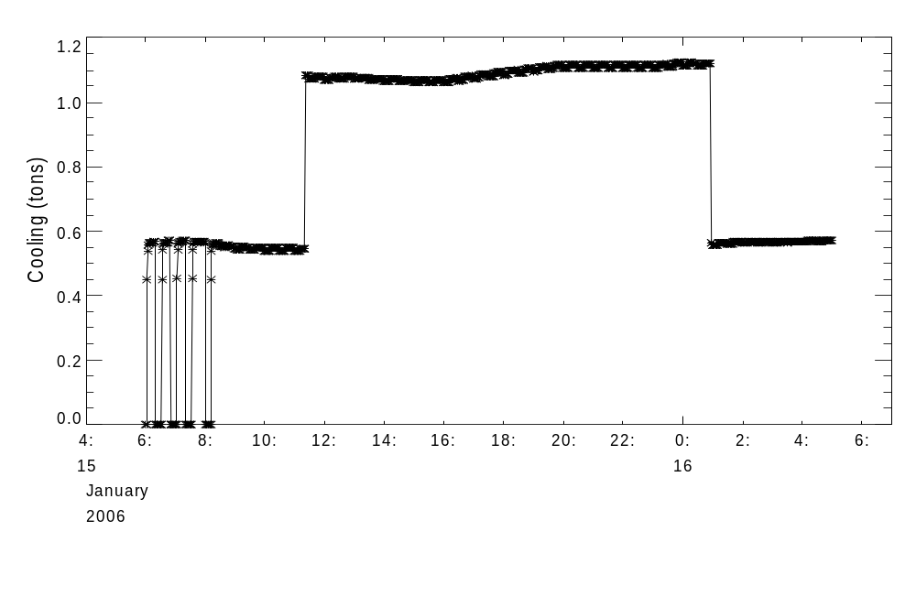
High stage comes ON 5% below the top of the deadband, after at least 6 minutes at low
Switch back to low stage 5% below the middle of the deadband
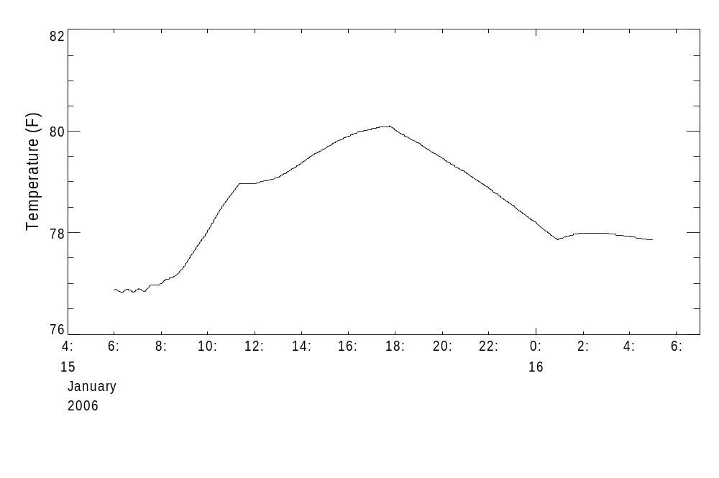
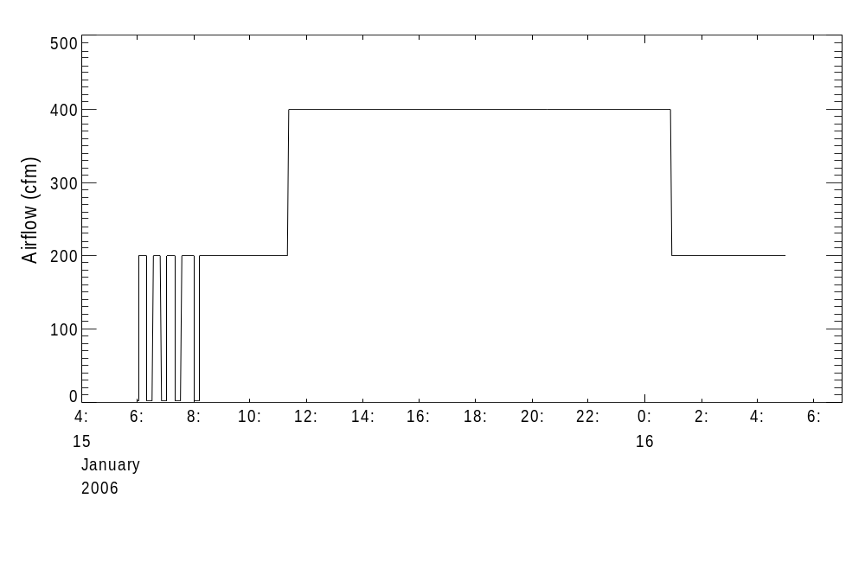

Low speed fan power is 0.3 x 200 = 60 Watts
High speed fan power is 0.35 x 400 = 140 Watts
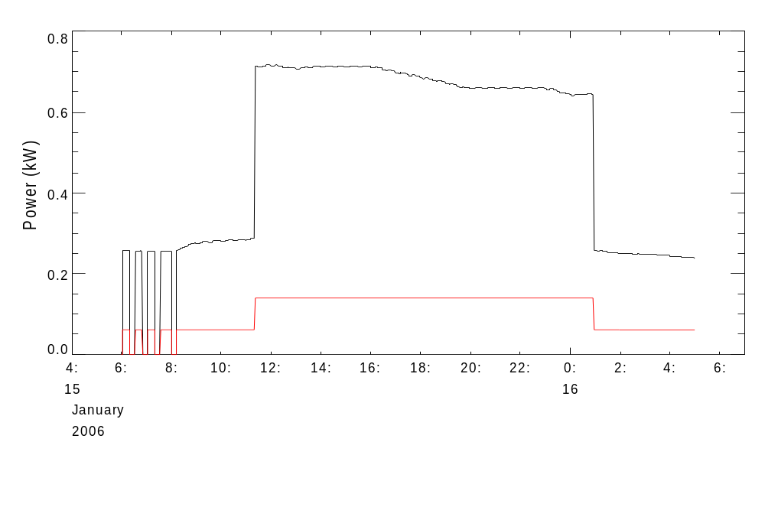
AC Power
Fan
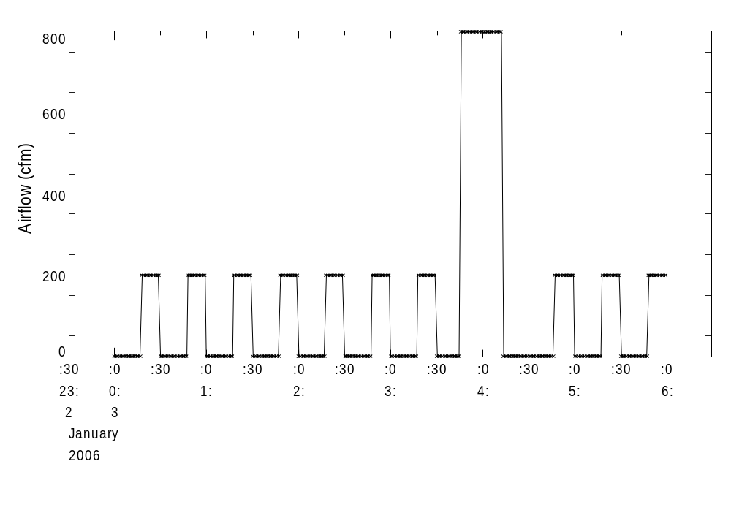
Low speed fan power is 0.3 x 200 = 60 Watts
High speed fan power is 0.3 x 800 = 120 Watts

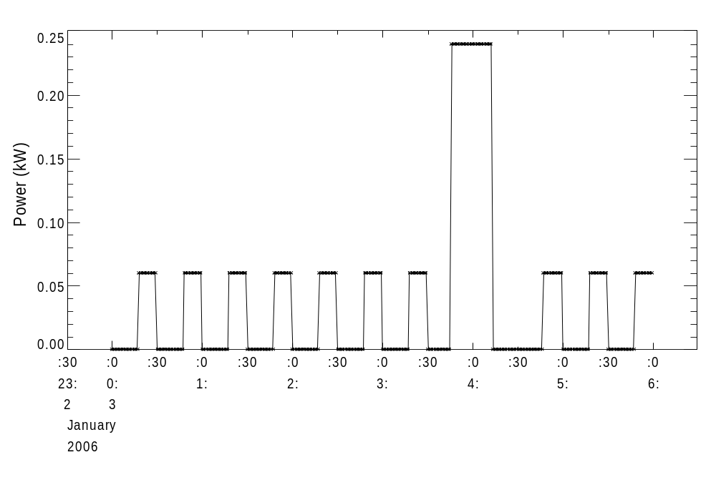
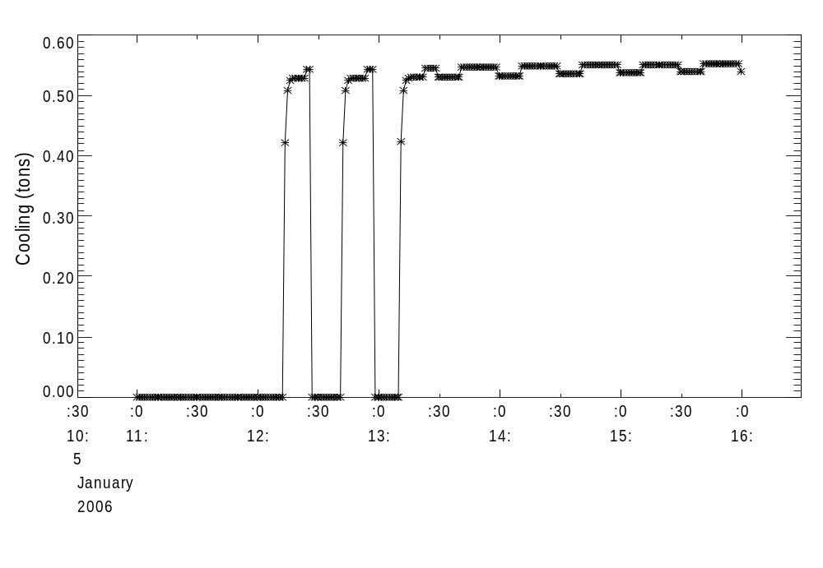
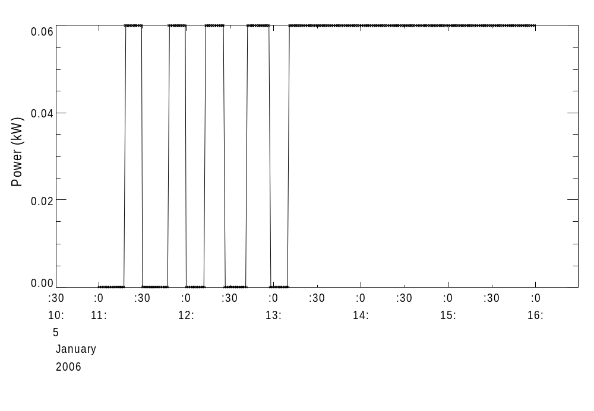
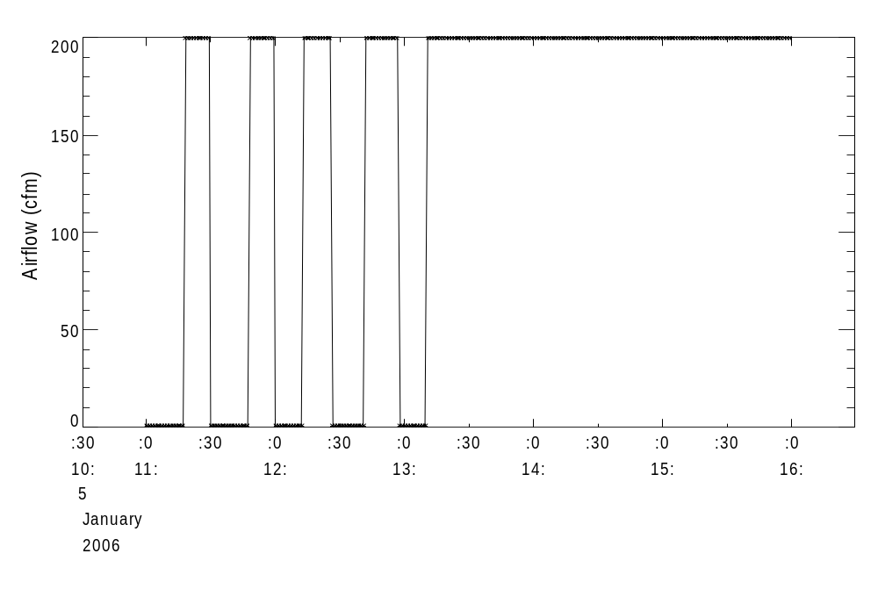
VARIABLE SPEED Jan 6 – PI Control pgain = 0.8, igain = .03

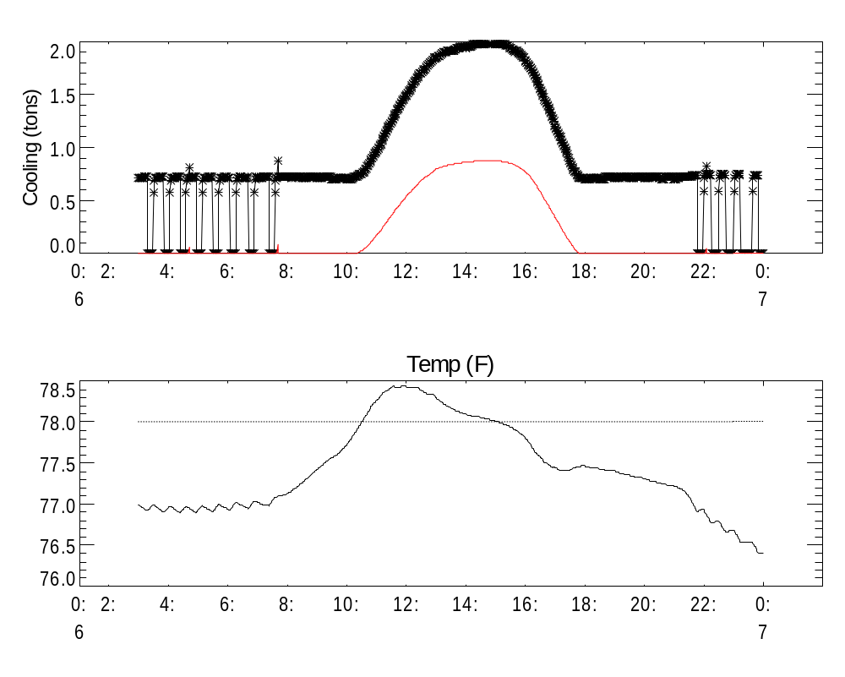
VARIABLE SPEED Jan 23 – PI Control pgain = 0.8, igain = .03
